RESUME
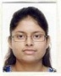

SRABANI MAZUMDER  E- mail  srabani.mazumder009@gmail.com  Contact Number  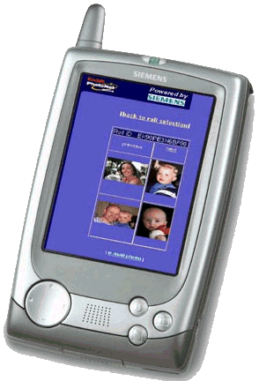  09874543012  09748033823  Permanent Address  1/A, SANATAN SEAL LANE  KOLKATA- 700012(WB)  Personal Data  Father's Name: Mr.Biplab Mazumder  Mother’s Name: Mrs.Alpana Mazumder  Date of Birth : 27th July,1990  Sex : Female  Nationality : Indian  Marital Status : Single  Languages : English  Bengali  Hindi  Hobbies  Reading fiction, biography  Involved in Creative writing  Travelling  Interested in music  Personality Traits:  Honest  Flexible  Good Learner  Optimistic  Aim of Life  To be a high-up in the professional field. | Career Objective  Can work using my own initiative as part of a team or on my own when required, providing quality service to the company.  Personal Skills  Willingness to enhance knowledge, Good communication skills, Ability to deal with people, Punctuality.  Platforms known  Ms-Excel, PowerPoint, Ms-Word  Favorable Subjects  English Literature, Political Science  Qualification  Qualified M.A. (English) in 2013 under University of Calcutta with 59.62%  Qualified Graduation in B.A(English Hons.) from Calcutta Girls’ College under University of Calcutta in 2011 with 57.4%  Passed the Higher Secondary Examination in the year 2008 from Gokhale Memorial Girls’ School (WBCHSE) Kolkata (WB) with 76%.  Passed the Secondary Examination in the year 2006 from Holy Child Institute (WBBSE) Kolkata (WB). With 80.5%.  Job Experience  Academic Content Developer in Adwin Enterprise (July.2015 - present)  Project Associate in Data Core India Pvt Ltd, a Development Consulting House.  (Sept.2014 – 2nd May.2015)  Job Profile: Project Associate in the Media Intelligence Dept. The multitasking post involves copy editing, video editing, proof reading and content writing of American commercials. The work requires tracking down American ads through exclusive software of Competitrack.

I hereby declare that the given above information are true to the best of my knowledge and belief and can be supported with reliable documents when needed

Date : (SRABANI MAZUMDER)

